Quelle heure est-il ?
Use the table below, as well as your time help sheet and previous worksheets, to help you complete the sentences for each clock below…
Il est | une | heure | et quart.  et demie.  cinq.  vingt.  moins le quart.  moins dix.  moins cinq.  etc.
 | deux sept douze  trois huit  quatre neuf  cinq dix  six onze | heures
midi
minuit

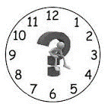 |  | 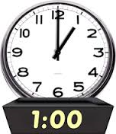
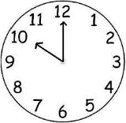 |  | 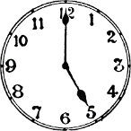
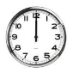
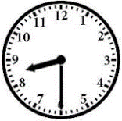 |  | 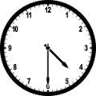
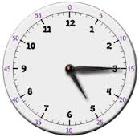 |  | 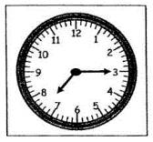
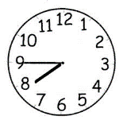 |  | 